|  |  |
| --- | --- |
| **Name** | Umar Hayyat |
| **Roll No** | EE-360 |

**Lab #01**

**Introduction to print statement**

**Objectives:**

1. How you print your name,roll no,section,session and department.
2. Print two numbers “x” and “y” and “x” raised to power “y”.
3. Generate two random numbers “x” and ”y” and then print addition, subtraction,division and multiplication of the two numbers .Also observe the output generated by the operation x%y.
4. Print out the area and circumference of the circle there pi=3.14 and r=4.
5. How you change the type of the integer to float and float to integer .Print out both number and observe result.

Try to print your name,roll no,section,session and department on output screen.

**Codes:**

print(‘Umar Hayyat’)

print(**'**360’)

print(‘Section B’)

print(‘Session 2019’)

print(‘Electrical’)

**Output:**

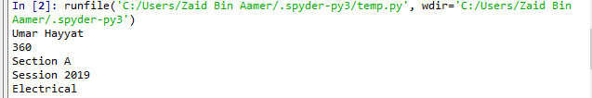

**Task No.02:**

Print out two numbers “x” and “y” then print out “x” raised to power “y”

**Codes:**

x=4

y=6

print(x)

print(y)

print(x**y)

**Output:**

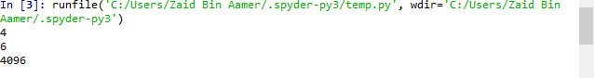

**Task No.03:**

Generate two random numbers “x” and “y” and then print addition,subtraction,division and multiplication of the two numbers .Also observe the output generated by the operation x%y.

**Code:**

import random

x=int(random.randrange(1,5))

y=int(random.randrange(3,8))

print(‘x=’,x)

print(‘y=’,y)

print(‘x+y’,x+y)

print(‘x-y’,x-y)

print(‘x/y’,x/y)

print(‘x*y’,x*y)

print(x%y)

**Output:**

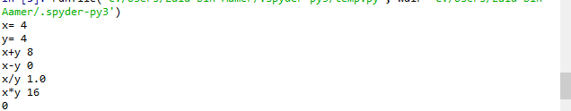

**Task No.04:**

Calculate and print the area and circumference of the circle .Take two variable “pi”and”r”.Assign “pi=3.14” and “r=4”

**Codes:**

pi=3.14

r=4

A=pi*r**2

C=2*pi*r

print('A=',A)

print('c=',C)

**Output:**



**Task No.05:**

Change the type of integer value to float and float to integer.Take two variable”x” and “y”.Save the integer value (e.g 5) in”x” and floating value (5.7) in”y”.

**Code:(part 1)**

**x=5**

**y=float(x)**

**print(y)**

**Output:**



**Code:(part 2)**

**x=5.7**

**y=int(x)**

**print(y)**

**Output:**



**Conclusion:**

In this lab we learnt how to:

1. Print our name,roll no,session and department using “Print” command.
2. Generate random numbers and show their addition,subtraction and division.
3. Do casting(change type of numbers)